**City and Municipal-level Small Area Poverty Estimates**

*Based on: https://data.world/open-crisis/ac853860-8c99-4499-80eb-984ddd7c1149*

Submitted by:

**Vincent Manalo**

BSIT 2

Submitted to:

**Mr. Lenuel Betita**

ITS 211 Subject Advisor

**SECTION 1. SUMMARY**

This research contains the interpretation of the researcher using the “Small Area Poverty Estimates in the Philippines 2009” gathered from “data.world”. It consist of 19 regions which are: NCR, Region I, Region II, Region III, Region IV-A, Region IV-B, Region V, Region VI, Region VII, Region VIII, Region IX, Region X, Region XI, Region XII, ARMM, Sulu, Tawi-tawi, and Caraga. With the help of the programming language, Python, the data was plotted into 6 different graphs to interpret poverty incidence of each city/municipality. The poverty incidence is the measure of the proportion of families or individuals who are in poverty. Here is the summary of the data:

Figure 1: The Poverty Incidence of the Cities/Municipalities of each Regions in the Philippines

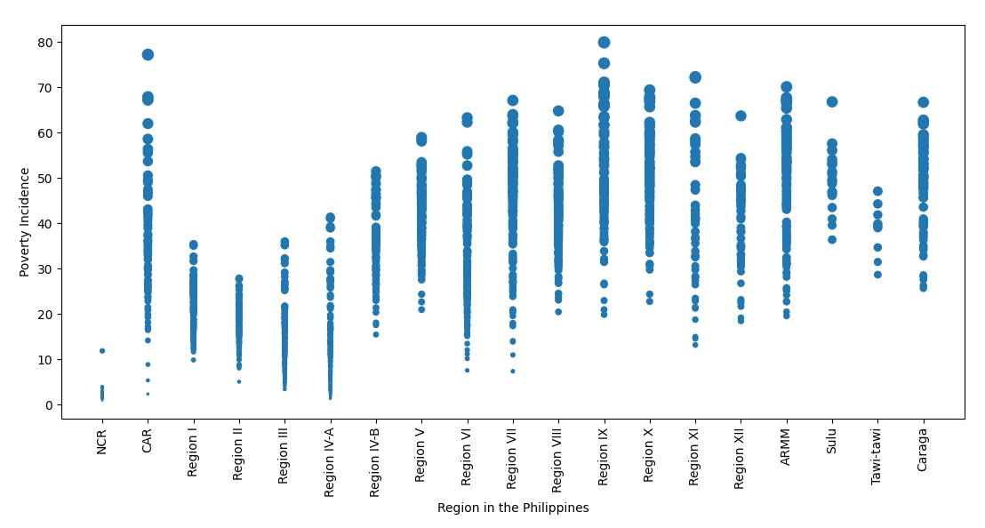

The Y-axis in the bubble graph above is the poverty incidence unit while the X-axis are the regions. The dots represents the cities and municipalities of each region and are plotted according to their poverty incidence. The Cordillera Administrative Region (CAR) and Region IX have the highest rate while NCR will have the minimum rate and minimum average.

**SECTION 2. CORDILLERA ADMINISTRATIVE REGION**

Figure 2. The Poverty Incidence of the Province of Abra in Cordillera Administrative Region

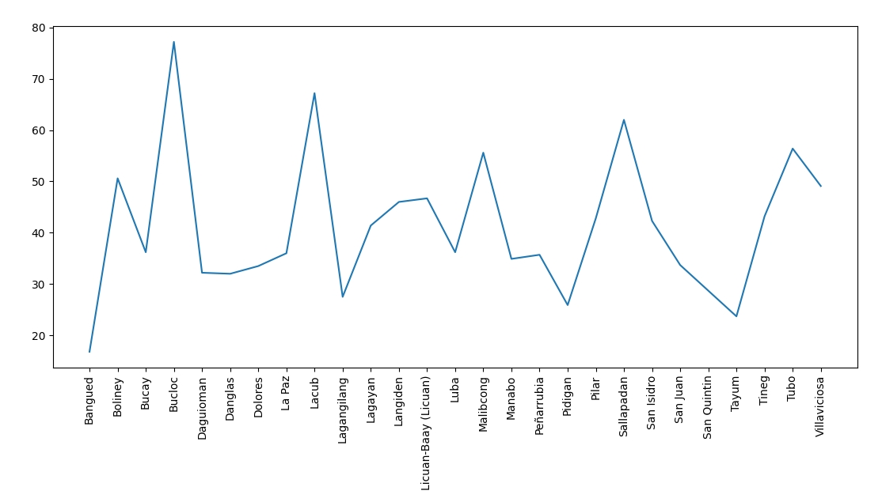

The Y-axis in the line graph above is the poverty incidence unit while the X-axis are the cities and municipalities of Abra. According to the table above, Bucloc has the highest rate while Bangued has the lowest.

**SECTION 3. NATIONAL CAPITAL REGION**

Figure 3. The Poverty Incidence of the 1st District in Cordillera Administrative Region

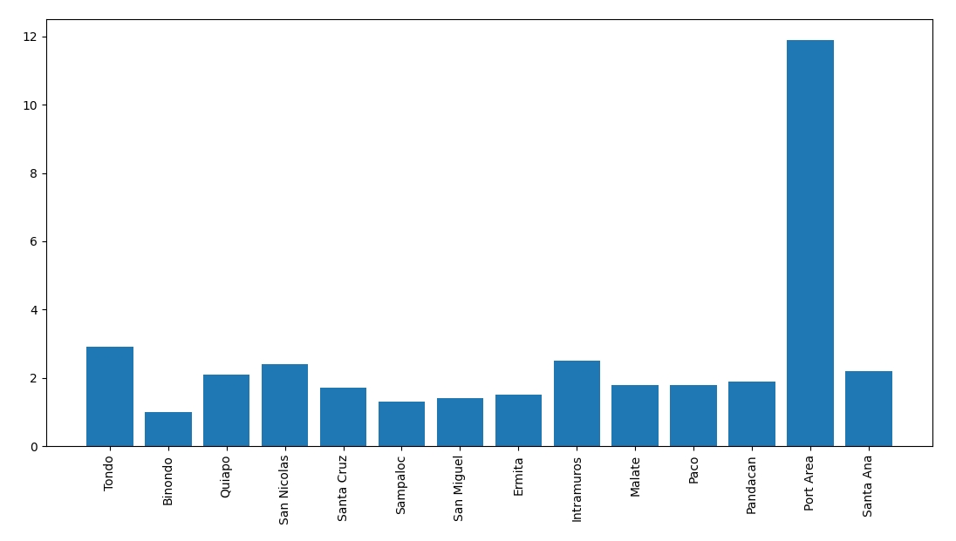

The Y-axis in the bar graph above is the poverty incidence unit while the X-axis are the cities and municipalities in the 1st District. According to the table above, the Port Area has the highest rate while Binondo has the lowest.

**SECTION 4. REGION I**

Figure 4. The Poverty Incidence of the Province of Ilocos Norte in Region 1

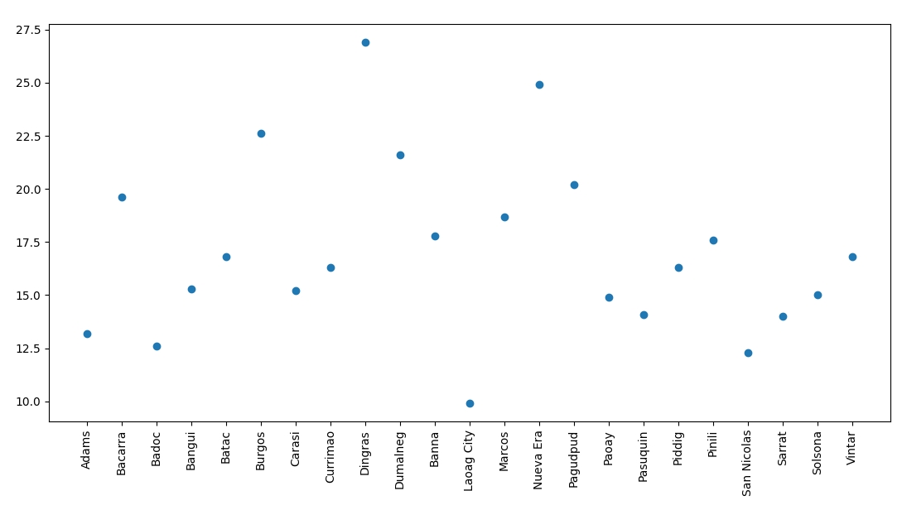

The Y-axis in the scatter plot graph above is the poverty incidence unit while the X-axis are the cities and municipalities of Ilocos Norte. According to the table above, Dingras has the highest rate while San Nicolas has the lowest.

**SECTION 5. REGION II**

Figure 5. The Poverty Incidence of the Province of Batanes in Region 2

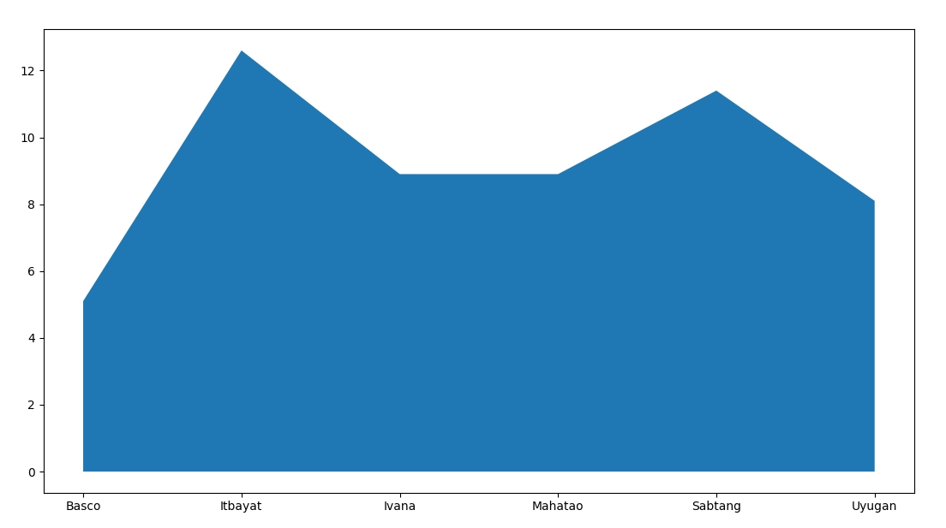

The Y-axis in the area chart above is the poverty incidence unit while the X-axis are the cities and municipalities of Batanes. According to the table above, Itbayat has the highest rate while Basco has the lowest.

**SECTION 6. REGION III**

Figure 6. The Poverty Incidence of the Province of Bataan in Region III

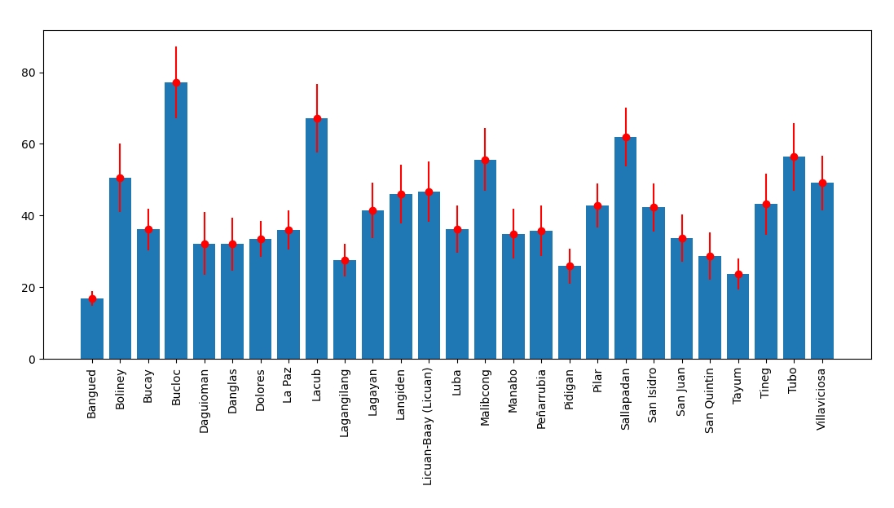

The Y-axis in the error bar graph above is the poverty incidence unit while the X-axis are the cities and municipalities of Bataan. The red lines are the Standard Error (SE) in the data gathered. According to the table above, Bucloc has the highest rate while Bangued has the lowest.

*Based on: https://data.world/open-crisis/ac853860-8c99-4499-80eb-984ddd7c1149*